Introduction to Selenium for Python Automation
Objective: To be able to learn automation techniques using Selenium by Python
Tools:
- Python 3.10.0
- Selenium 4.47.0
Concepts Used:
- Installing Selenium
- Writing First Script
- XPATH and CSS Selectors
- Automating Form Submission
- Capturing Screenshots
- Data-Driven Testing
- Error Handling
- BeautifulSoup for Automating Web Scraping
- Drag and Drop
- Implicit and Explicit Wait
SELENIUM INSTALLED
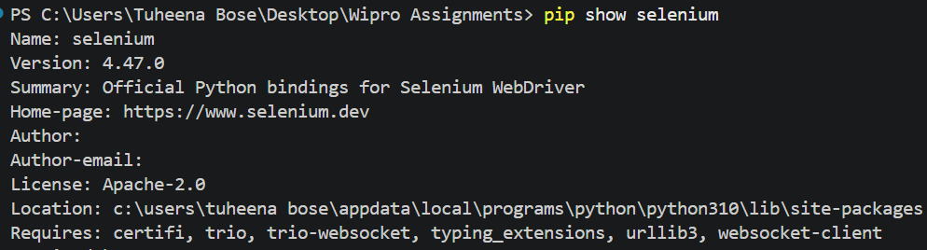
WRITING FIRST SCRIPT
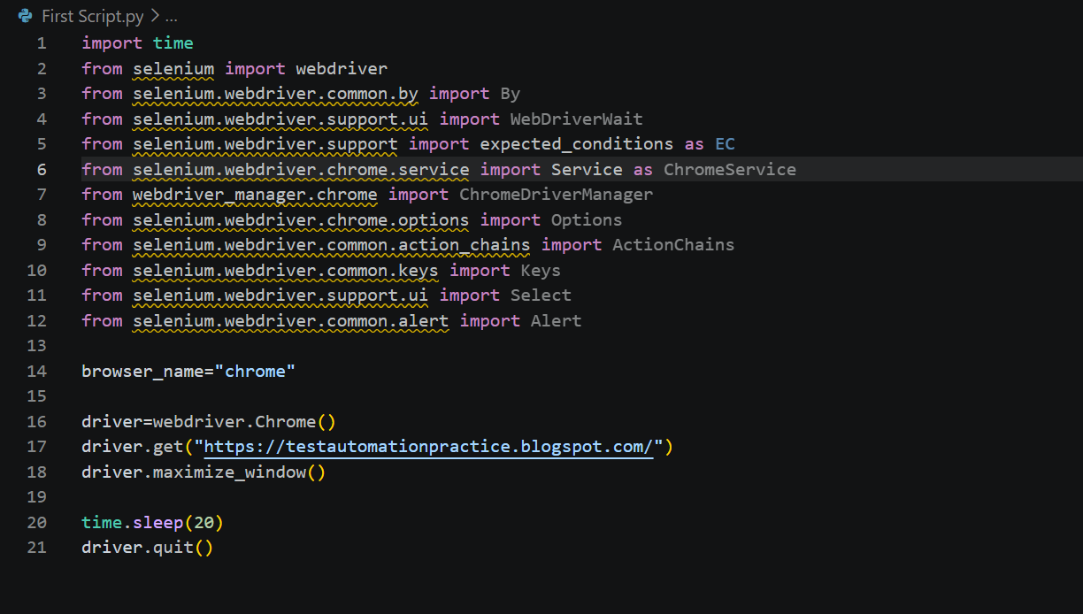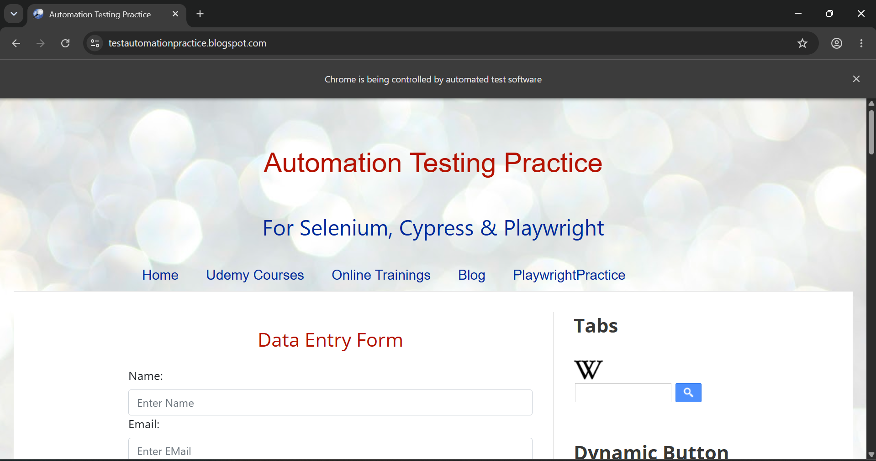

XPATH and CSS Selectors
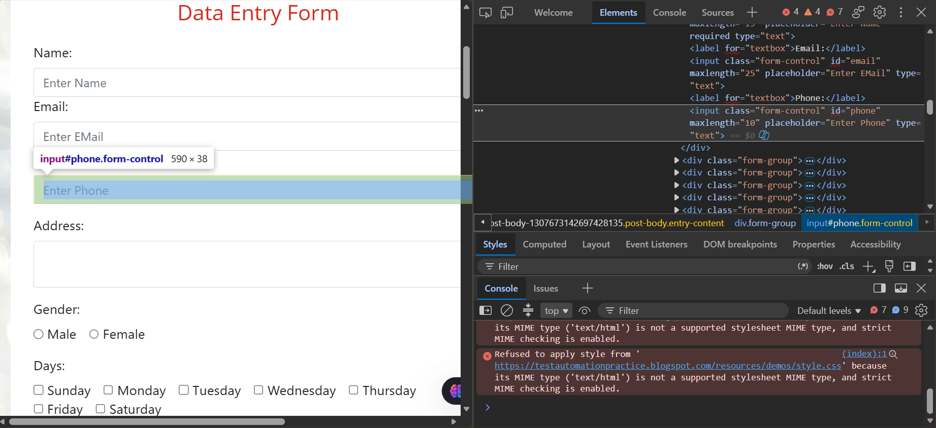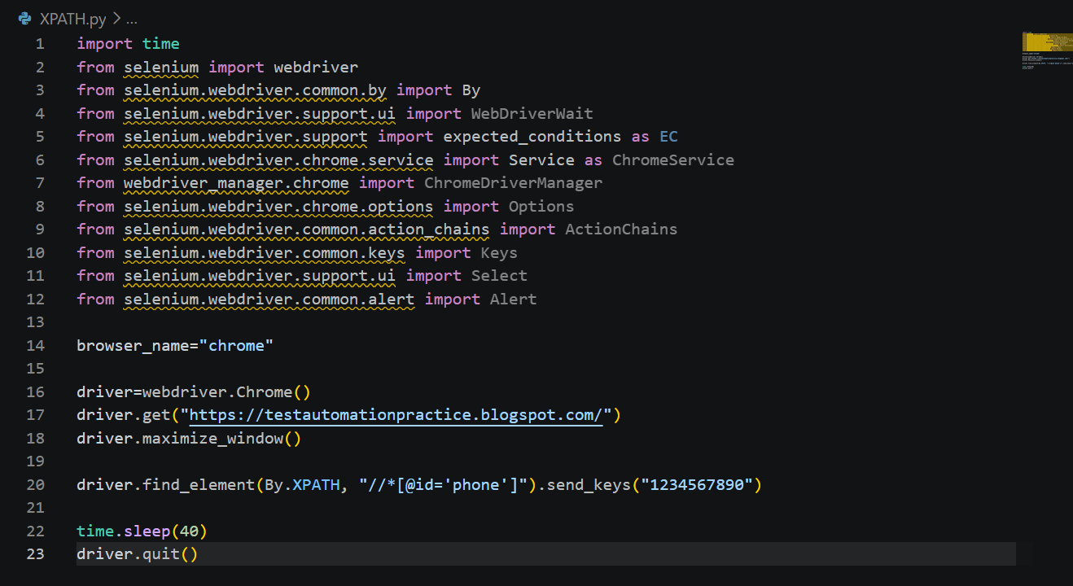
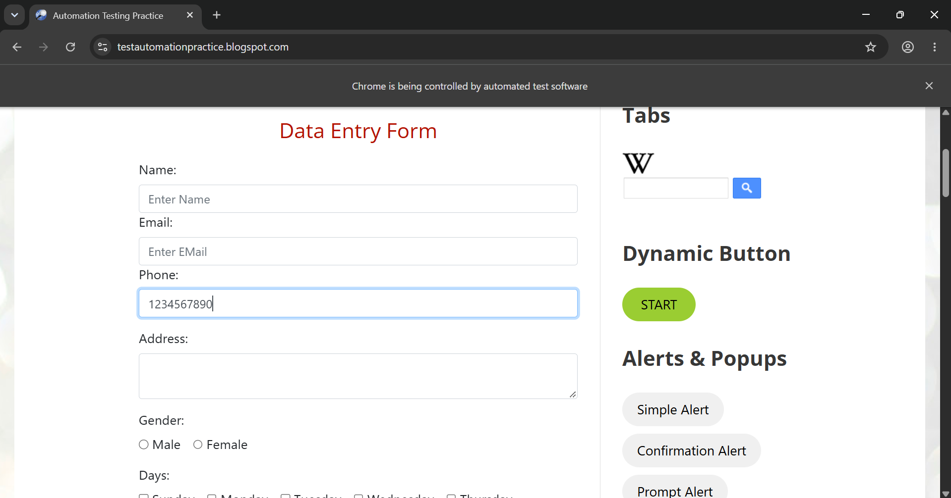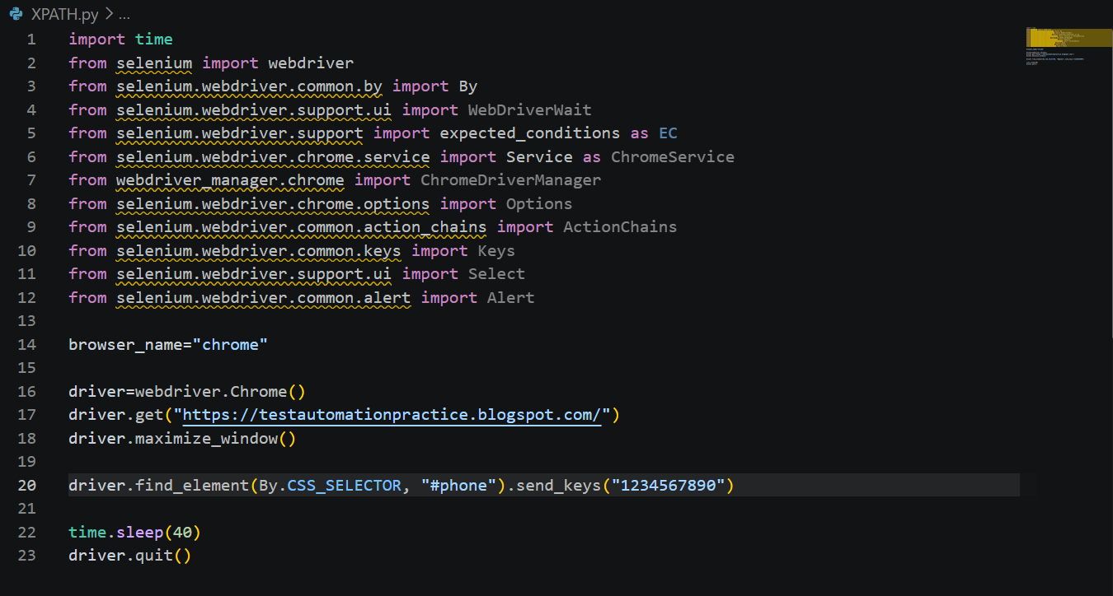
AUTOMATING FORM SUBMISSION
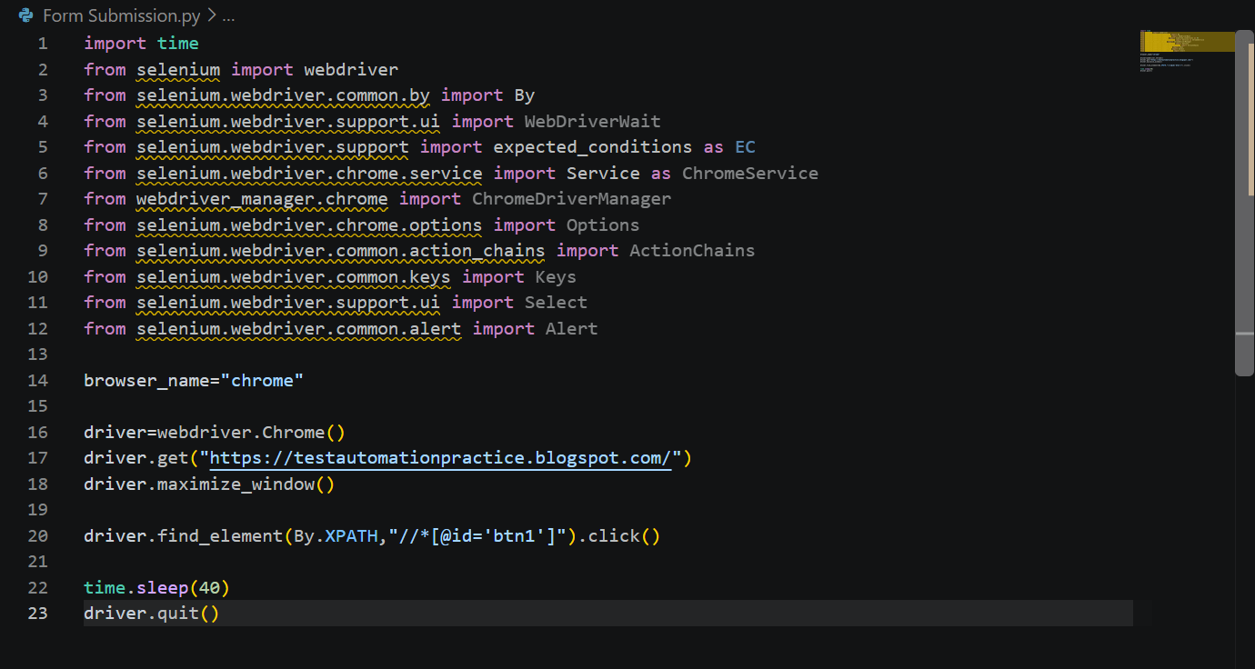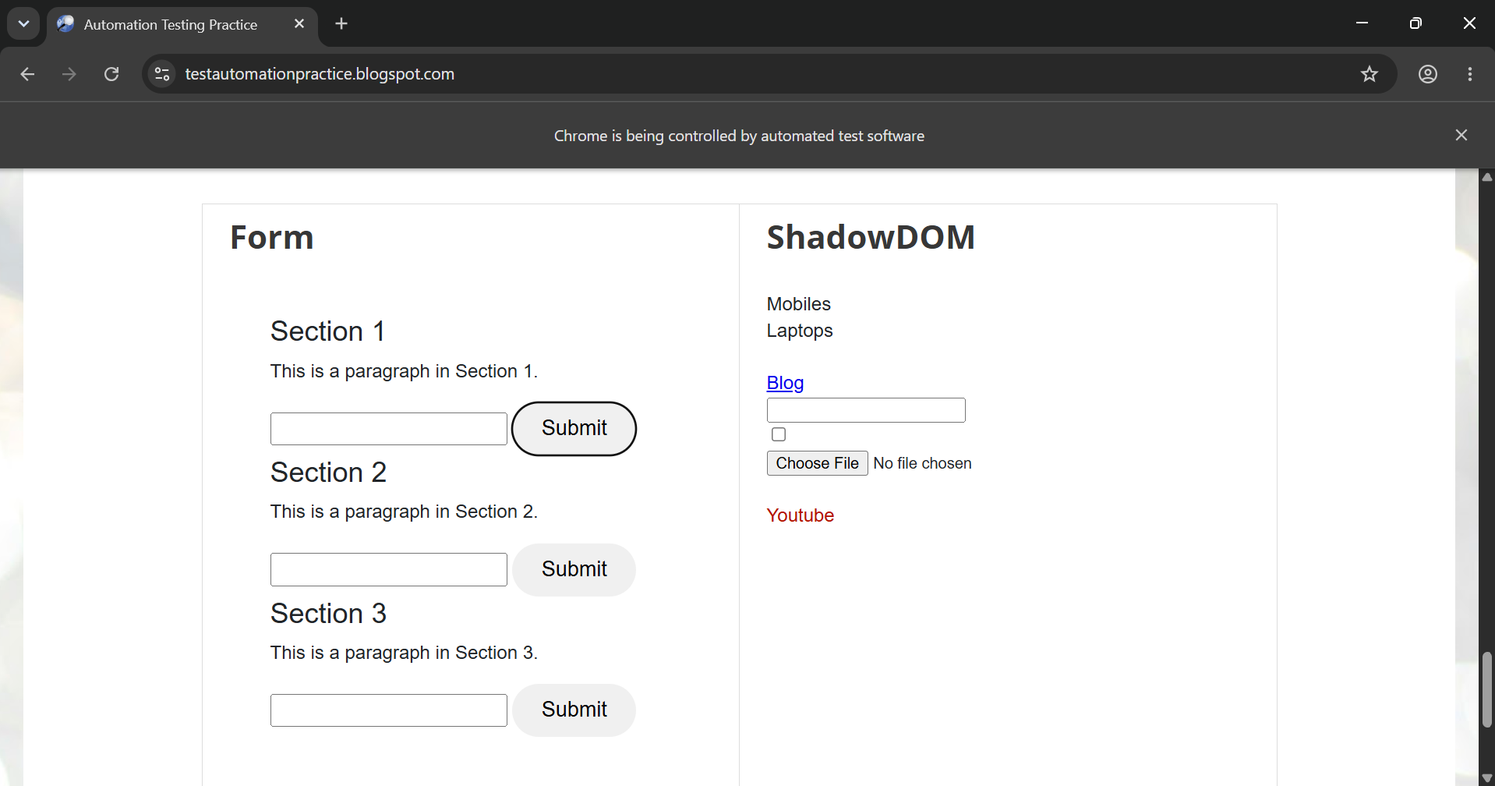

CAPTURING SCREENSHOT
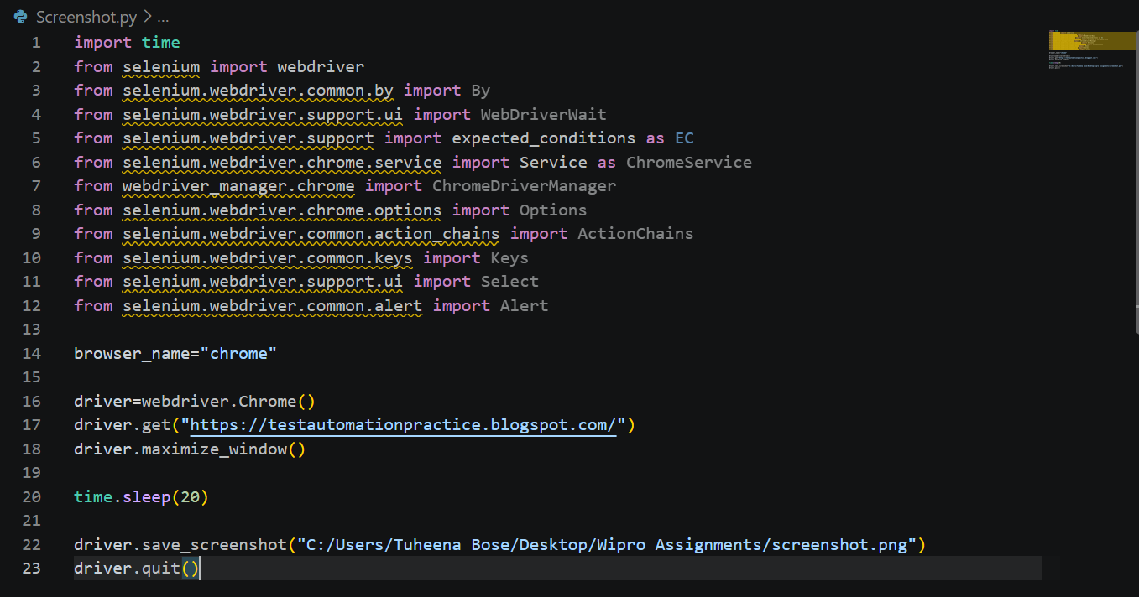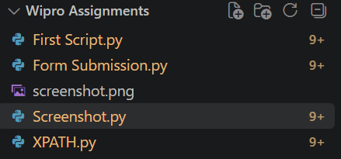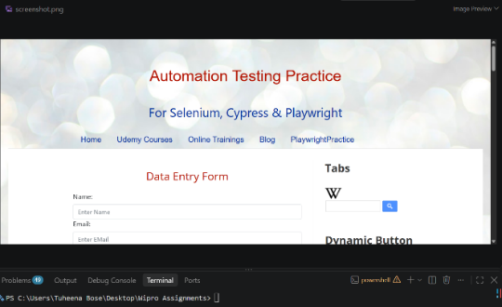
DATA DRIVEN
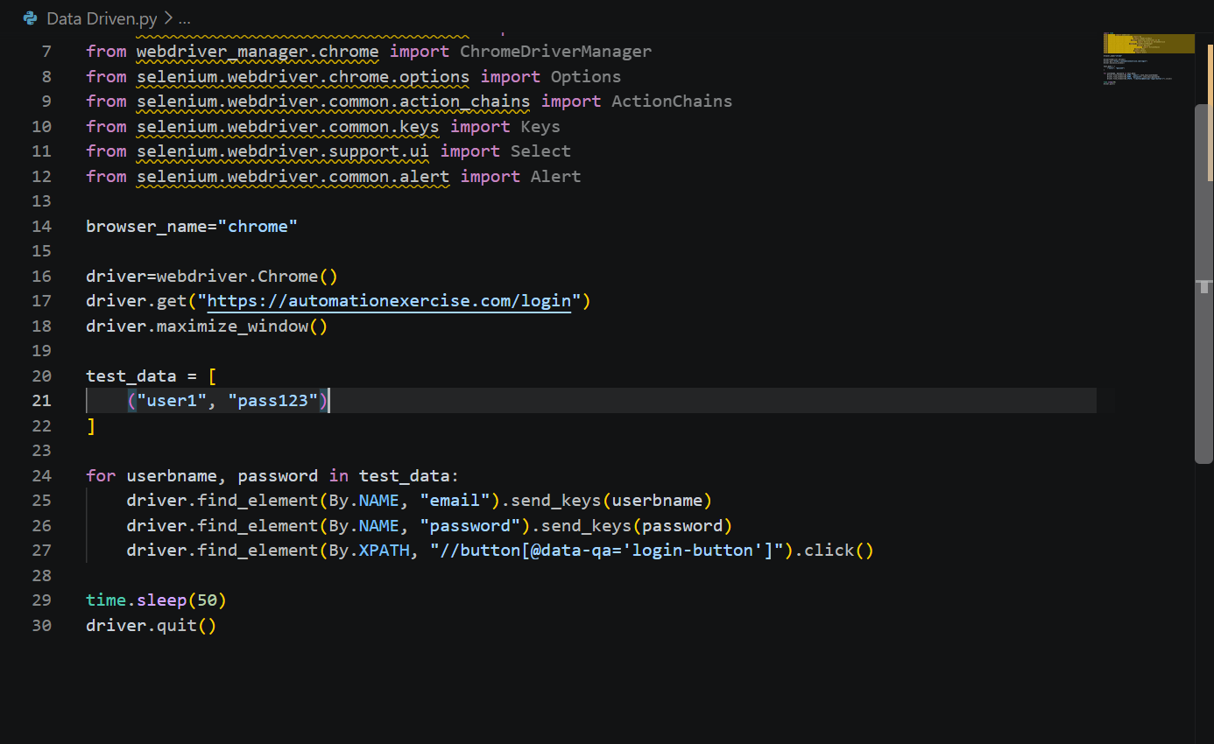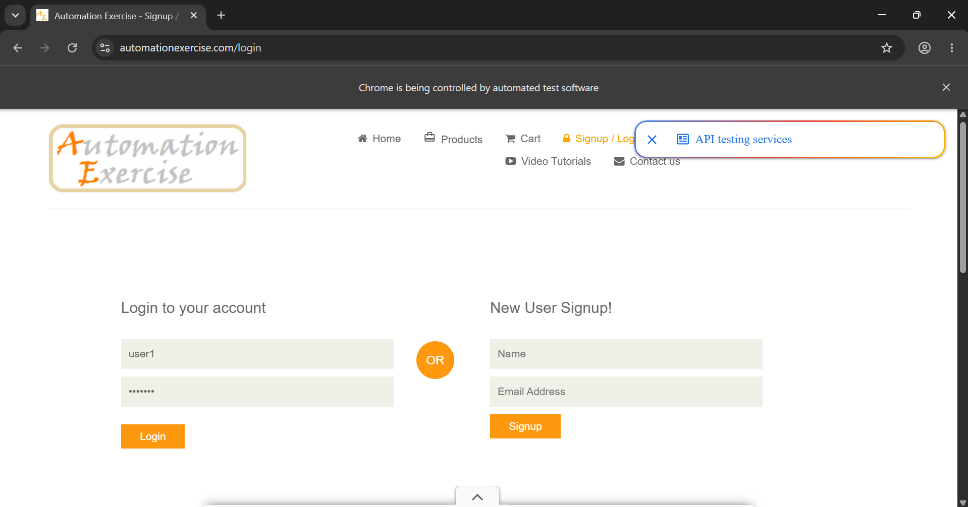
ERROR HANDLING
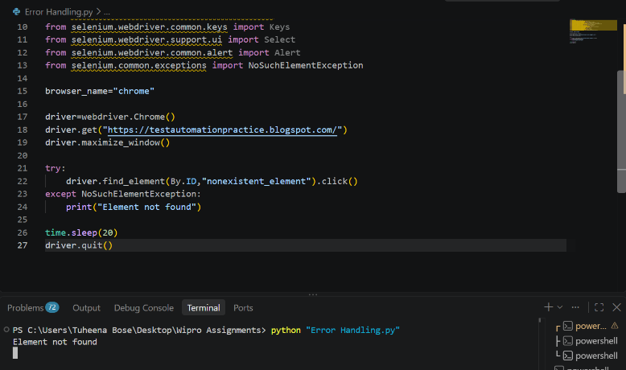
BEAUTIFUL SOUP FOR AUTOMATING WEB SCRAPING
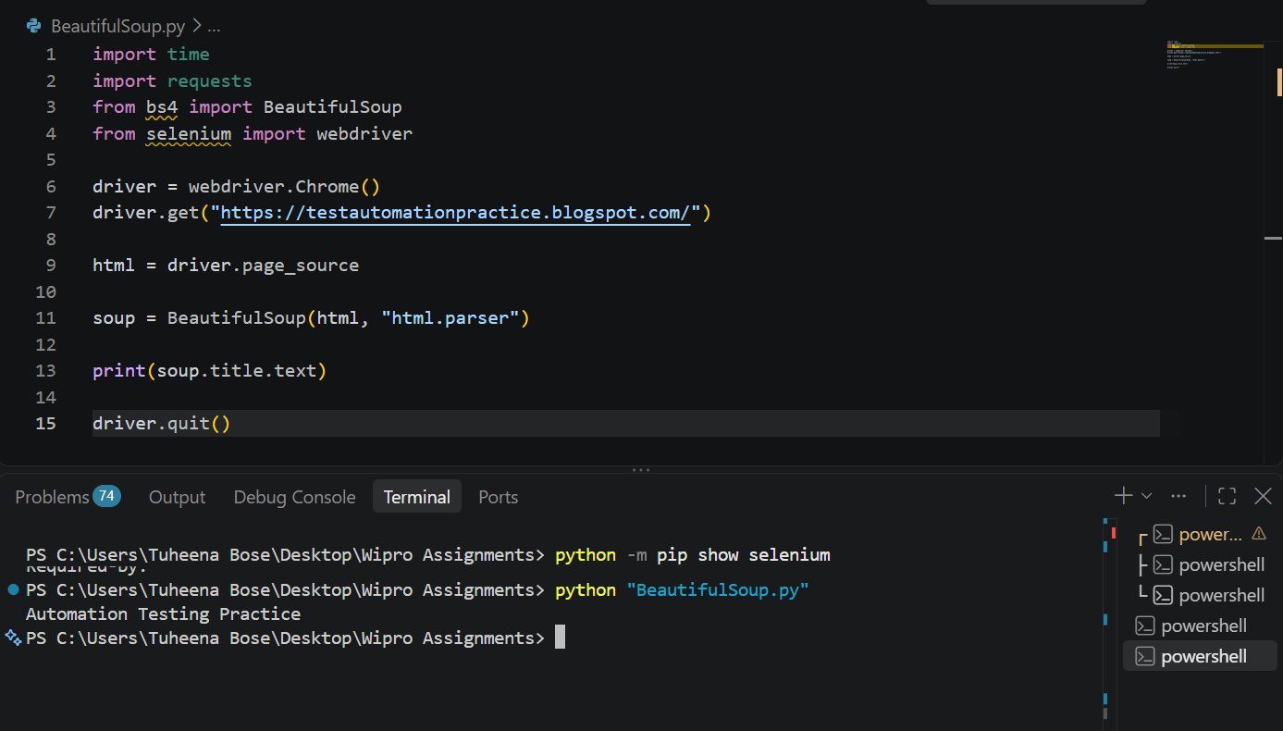

DRAG AND DROP
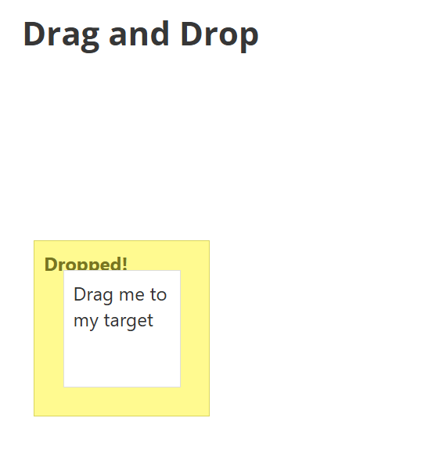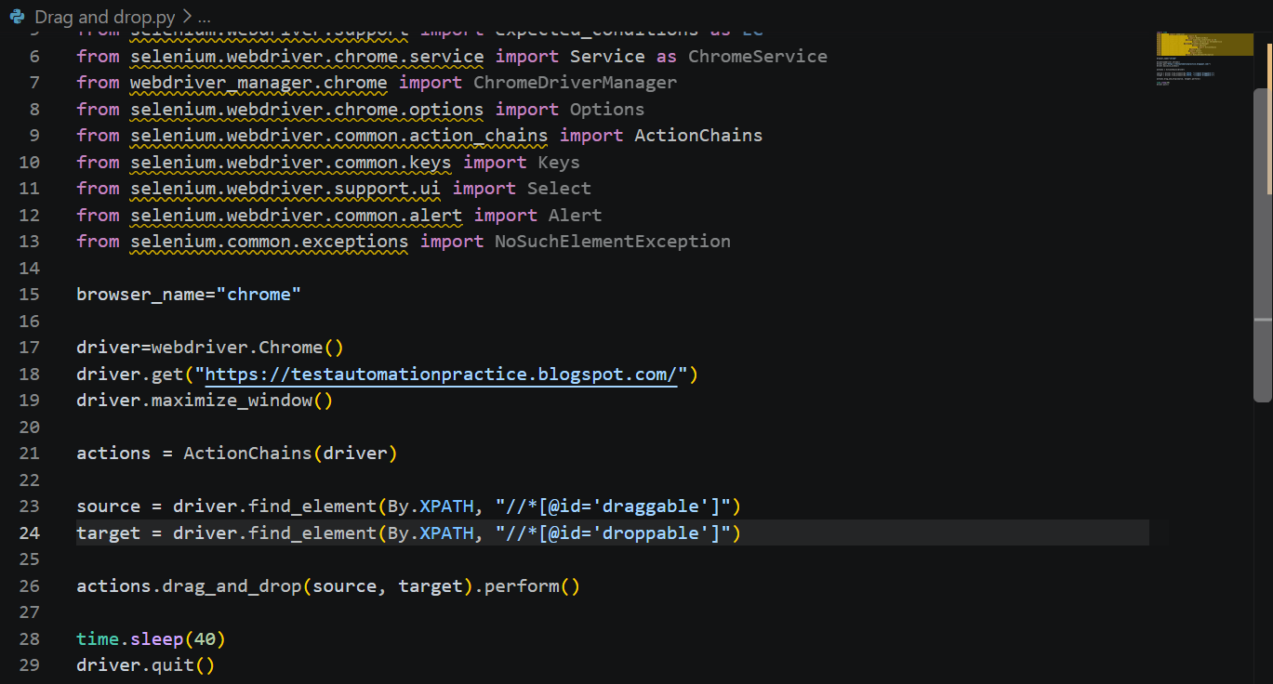
IMPLICIT WAIT
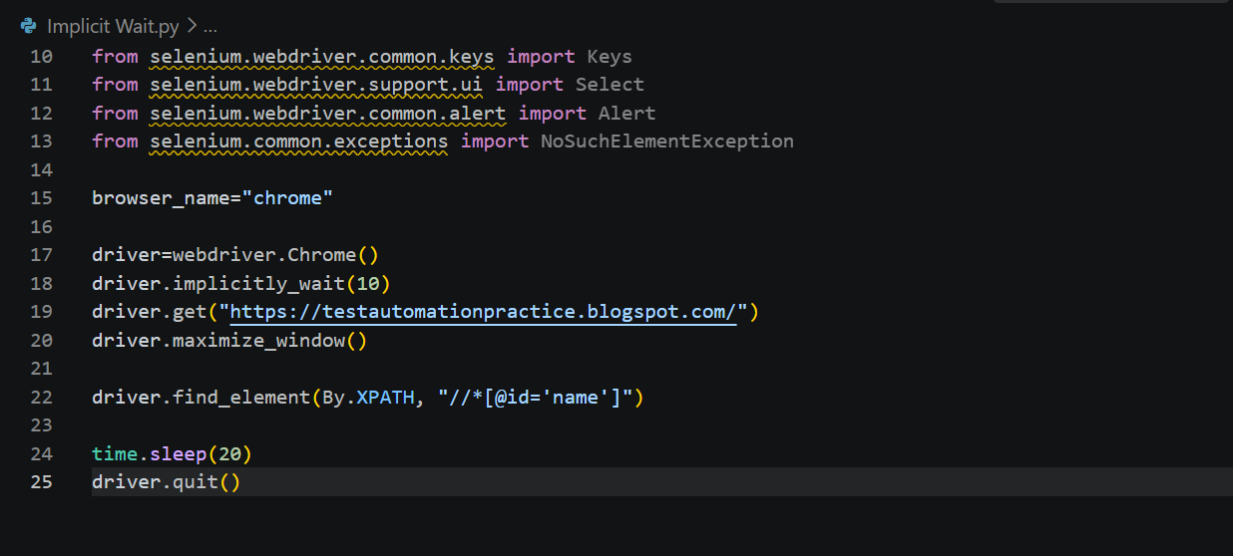

EXPLICIT WAIT
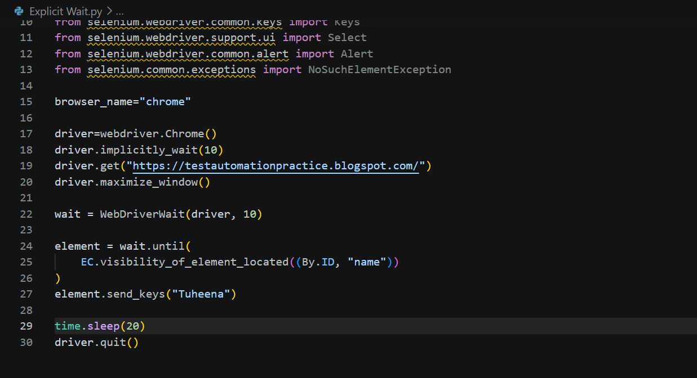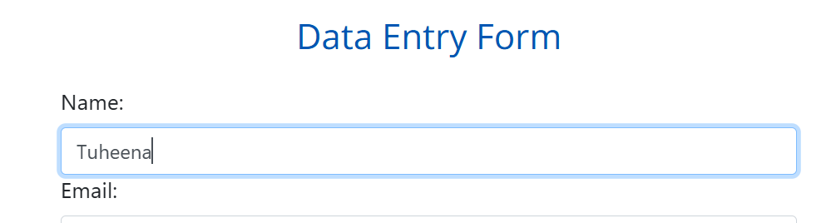

Conclusion
This module led to the beginning of understanding the easier aspects of learning automation by python using selenium.

